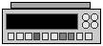

SENTEK
Unit 6 & 7 Crittall Court, Crittall Drive, Springwood Industrial
Estate, Braintree, Essex, CM7 2SE
Tel: +44 (0) 1376 340 456 Fax: +44 (0) 1376 340 453 Email: sentekuk@btconnect.com
150mV
300mV
Mono/Reference
Combination
The Ammonia Gas Sensing Probe

- Theory

  - Introduction

The ammonia gas-sensing probe is one of a series, which respond to the partial pressure of an analyte gas in solution.

The ammonia in solution is released by increasing the pH and is transferred across a gas permeable membrane into a thin film between the membrane and a flat glass pH electrode. The response of the probe changes until the partial pressure of ammonia in the thin film is equal to that in solution. The change in partial pressure of ammonia alters the pH at the glass electrode. It is this change that is measured in mV and related to the concentration of ammonium in solutions.

The response of the probe is Nernstian up to a concentration of 10⁻¹ M ammonia, but the lower limit is set by the purity of the water available.

This booklet describes the assembly and use of the ammonia probe and the equipment necessary for use. It should be read carefully before attempting to use the probe.

1.2 Construction of the Ammonia Probe

The ammonia probe is a combination electrode. It consists of an electrode pair. The sensing membrane is a flat faced glass pH electrode and the reference electrode is a silver/silver chloride wire.

The electrode pair is separated from the sample solution by a gas-permeable membrane. The junction between the two electrodes is completed with a filling solution containing ammonium ions.

When the membrane (which is fixed into a detachable cap) is tightened against the glass electrode, a thin layer is produced and this thin layer acts as a sensor responding to changes in the partial pressure of ammonia in a sample solution. The complete electrode is shown in Figure 1.

  - Response

Gas-sensing probes are complete electrochemical cells consisting of a pH and a silver-silver chloride electrode (Fig. 1). The glass electrode is separated from the sample by a thin film. Any change in the partial pressure of ammonia in the thin film causes a change in response at the glass electrode, which is registered on a mV meter.

The thin film between the pH electrode and the membrane contains ammonium dissociating according to the equation

NH₄OH NH₃ +H₂O

When the probe is introduced to sample containing ammonia, the ammonia diffuses across the membrane, upsetting the equilibrium and thus the pH of the thin film. This change continues until the partial pressures of ammonia on either side of the membrane are equal.

The relationship between the e.m.f. of the probe and the ammonia concentration can be considered with respect to the cell.

Ag/AgCl/mM. NH₄Cl// mM. NH₄Cl, vM. NH₃/glass electrode

where mM is the molar concentration of the ammonium chloride solution and v is the number of moles of ammonia that have diffused across the membrane. The potential generated by this cell is described by

E = Eº_{glass} + k log (a_{H}+) - Eº Ag-AgCl + K log (a_{Cl-}) ….(1)

Which can be abbreviated to

E = E¹ + k log (a_{H}+) ….(2)

The dissociation constant K for ammonium ion is

K = a_{H}+ (ªNH3/_{aNH4+}) ….(3)

Which substitutes into equation (2) gives

E = E¹¹ + k log (C_{NH4+}) - k log (C_{NH3}) ….(4)

As the dissociation constant is very small, equation (4) can be abbreviated to a form which the potential E is related directly to the ammonia concentration of a solution

E = Eº gas - k. log (C_{NH3})

This equation is similar in form to the Nernstian for ion selective electrodes and can be used in the same way.

  - Equipment required for the use of an ammonia probe

The equipment required for the use of an ammonia probe is similar to that required for the measurement of pH and with ion selective electrodes. The first requirement is a millivolt meter with a high impedance input, reading over a range 0-1400mV or over an expanded range (i.e. 0-100 or 0-200mV). Most modern pH meters will fit this requirement.

Also needed for ammonia measurement are a magnetic stirrer to aid the release of ammonia from a sample solution, ammonium standards, sodium hydroxide buffer to adjust the pH, and conical flasks (100ml) to contain standards and samples.

- The Use of the Ammonia Probe

  - Assembly

The ammonia probe kit consists of the ammonia probe, two caps with fixed gas-permeable membranes and a filing solution. Assembly for use is as follows:

- Fix the membrane cap to the body covering the face of the flat pH electrode and screw it about two-thirds on to the thread.
- With a syringe fill the electrode with 3-4ml of filler solution.
- Tap the electrode gently while upright to move any air from between the membrane and the pH electrode.
- Tighten up the cap, until pressure on the membrane is felt (finger-tight).
- The electrode is ready for use on connection to a pH meter.

  - Preparation of Standards

- For 1.0M Ammonia as ammonium chloride, dissolve 53.49g Analar NH₄Cl in distilled water (1 litre). For best results distilled/de-ionised water should be used. Prepare 10⁻¹ to 10⁻⁵M Ammonium solutions by serial dilution.
- For a 1000 ug. ml⁻¹ solution of NH₃ as Ammonium Chloride dissolve 3.15g Analar NH₄Cl in distilled water (1 litre)
- Prepare a 1.0M Sodium Hydroxide solution.

  - Calibration and Measurement

The ammonia probe is calibrated in the same way as one would calibrate an ion selective electrode.

- To 10⁻¹M Ammonium Chloride (50ml) in a 100ml conical flask add 5ml of 1.0M sodium hydroxide. Stir gently for a few seconds. Then dip the probe into the solution taking care not to immerse more than two-thirds of the cap.
- Switch on the pH meter and allow the mV reading to stabilise. On initial reading this may take up to 20 minutes, as the membrane must be 'wetted'. Note the final mV reading (E). This can be expected to be about -300mV.
- Remove the probe, rinse the cap using a wash bottle, touch dry with a tissue, then dip the probe into a 10⁻²M Ammonium chloride standard, prepare in the same way as the first standard. Note the mV reading.
- Repeat the procedure over the required range of standards. For decreasing concentration the slope will be positive.
- Plot E versus Log C_{NH3}
- By treating samples in the same way as standards (50ml + 5ml of sodium hydroxide, the ammonia concentration can be found by reference to the calibration graph.

N.B. Care must be taken to ensure that all standards and samples are at the same temperature.

  - Interference's

The ammonia probe is in this respect almost an ideal sensor. The interferences on its performance are minimal. The membrane is hydrophobic, so anions and cations cannot interfere with response. Ammonia itself is a basic gas, so that acid gases such as CO₂, SO₂, and NO₂ are not released from solution at the low pH used for measurement of ammonia.

However, interference does occur from volatile or filming amines in solution such as hydrazine or cyclohexylamine. These produce an increase in apparent ammonia concentration.

  - Response Time

At high ammonia concentrations .g. 10⁻¹, 10⁻², 10⁻³M. NH₄Cl in solution, the response of the probe is normally quite fast. However, since its response is linked to an equilibration of partial pressure on both sides of a membrane, it will not be as fast as an ion selective electrode. An approximate performance would say be

- 30-40 secs to equilibrate for changing concentration between 10⁻¹ and 10⁻²M NH₃
- 1-1½ min between 10⁻² and 10⁻³
As the concentration decreases further, the response time increases quite considerably. 5-15 minutes is not uncommon.
- For increasing concentration the response time is very much faster. 30-35 seconds or a ten-old increase in concentration it to be expected.

  - Probe Range

The ammonia probe is usually Nernstian over the range 1.0M to 10⁻⁵M if care is taken in the purification of water used. However, this range can be extended if purified waters are used for preparation of standards.

  - Temperature Effects

The ammonia probe has a temperature coefficient of +1-2mV/ºC and should not be used in direct sunlight or in areas of rapidly changing temperature. Standards and samples should be held at constant temperature.

- Troubleshooting

- Drift until meter limits:

This suggests an open circuit between the pH and reference electrode. The answer is to increase the amount o filler solution in the electrode to cover the reference electrode.

- Very slow continuous drift:

Suggests a leaking membrane. Replace the membrane and repeat Section 2.1.

- Noisy reading at the pH meter:

Suggests air between pH electrode and membrane or an outer membrane. Loosen the membrane cap and tap the electrode as described in Section 2.1 (iii).

4. References

- Performance Characteristics of Gas-sensing Membrane Probes.
Bailey P. L. and Riley M, Analyst, 100 (1975), 145.

- Determination of Ammonium Nitrogen in Animal Slurries by an Ammonia Electrode.
Byrne E. and Power T., Comm. Soil Sci. Plant, 5 (1), 1974, 51.

- Rapid Determination of Plasma Ammonia using an ion selective electrode.
Attilli A. F. et. al., Biochem. Med., 14, 1975, 109.

- Selective Electrode Measurements of Ammonia in Water and Wastes.
Thomas R. F. and Booth R. L., Environ. Sci. Technol., 7 (6), 1973, 523.

- Measurement of Ammonia in Musts and Wines using a Selective Electrode.
McWilliam D. J. and Ough C. S., Amer. J. Enol. Viticult., 25 (2), 1974, 67.

- Determination of Ammonium in Soil Extracts and Water Samples by an Ammonia Electrode.
Bornwart W. L. et al., Comm. in Soil Sci. and Plant Anal., 3 (b), 1972, 449.

- Determination of Ammonia in Aquaria and Sea Water using the Ammonia Electrode.
Gilbert T. R. and Clay A. M., Anal. Chem., 45 (9), 1973, 1757.

- Electrometric Ammonia Determination in Plasma.
Sanders G. T. B. and Thornton W., Clin. Chim. Acta., 46, 1973, 465.

- Estimation of Nitrogen with an Ammonia Probe.
Buckee G. K., J. Institute Brewing, 80, 1974, 291.

- Potentiometric Water Analysis.
Midgley D. and Torrance K., Wiley Interscience, 1978.

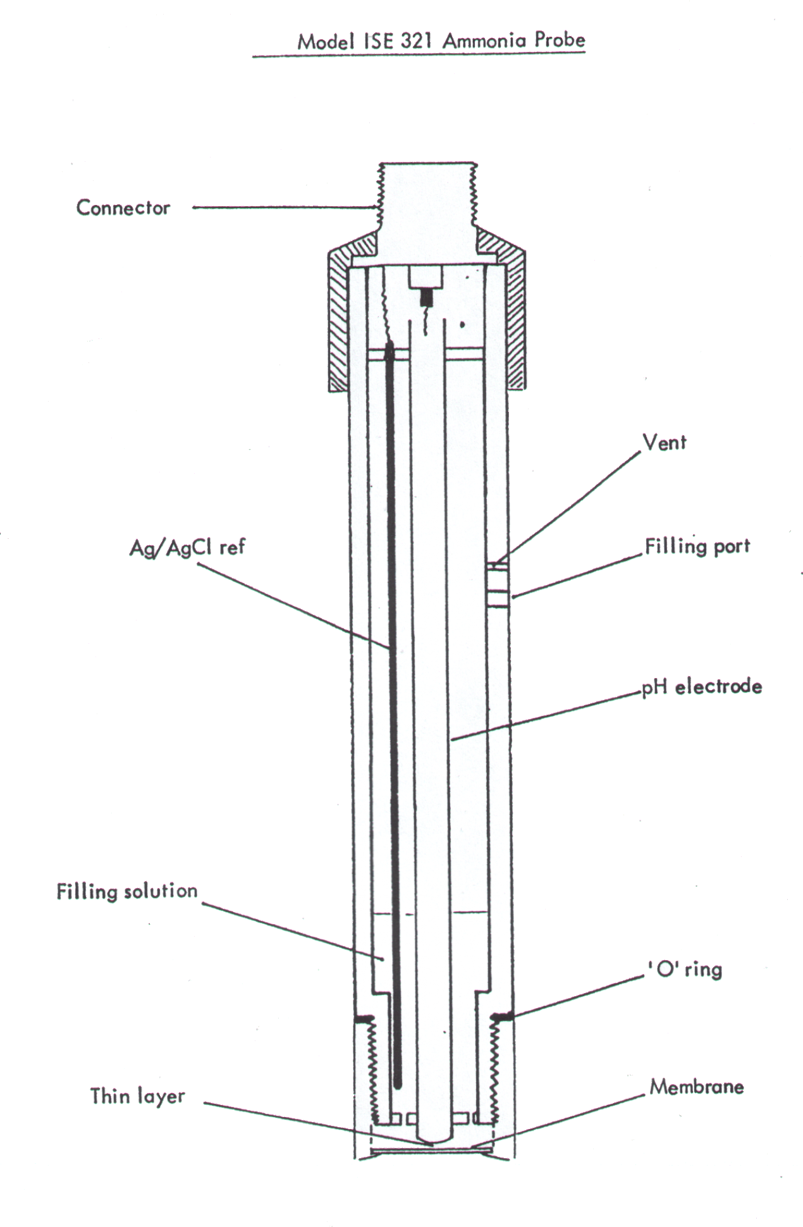

or Cable

