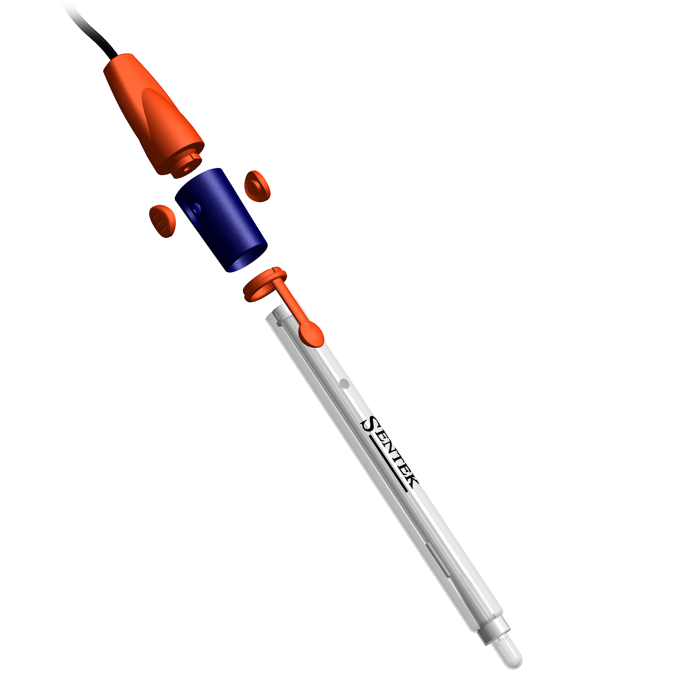
SENTEK

ADDITIONAL INSTRUCTIONS

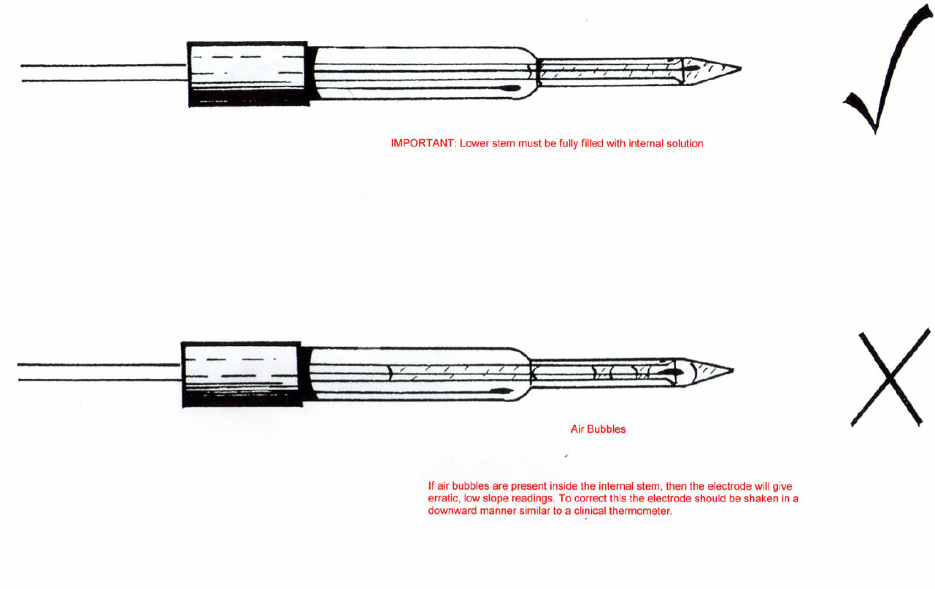
On receiving your electrode please ensure that there are NO air bubbles in the lower stem of the electrode. As shown below:
Prior to using:
Soak the electrode in cleaning solution
(791-15) overnight.
After every days usage soak the electrode in
Cleaning Solution (791-15)
Overnight – Every Night
For Long Term storage, clean overnight in Cleaning Solution, Rinse thoroughly with DI Water and refit black soaking boot filled with KCL and store in a cool place.

